**Information Notice**

**Statutory Rule Title** **Retail Leases Regulations 2013**

**Information Title:** **Correction**

**Version:** **001**

In item 33.7 of Schedule 2, for:

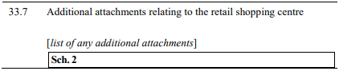

substitute:

